Problem 64

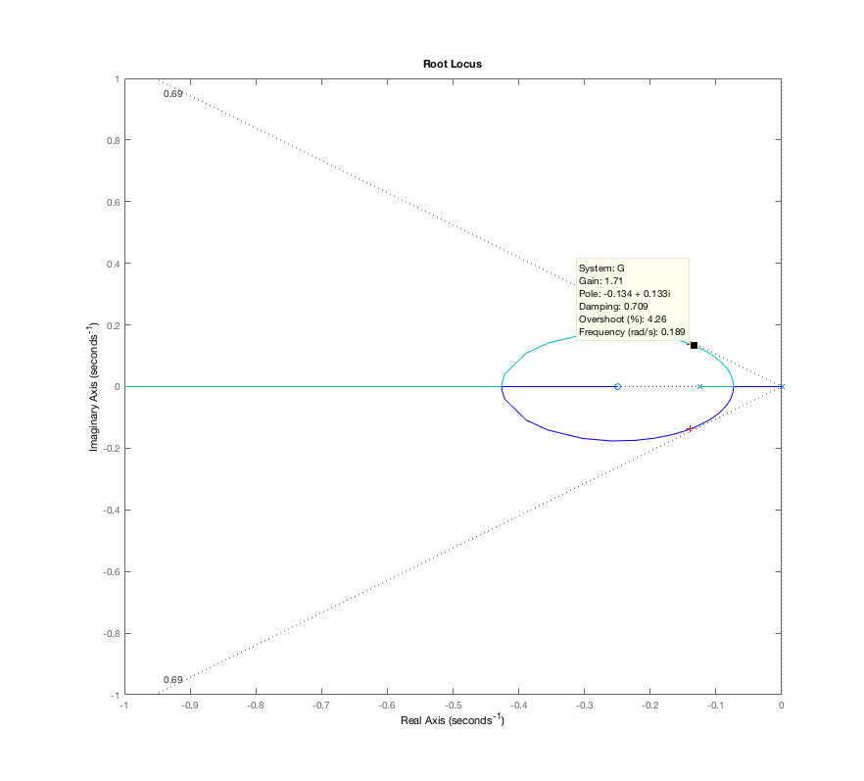

J1 = 10;

B1 = 1;

k = 100;

Jm = 2;

Bm = 0.5;

os = 5;

p1 = [J1 B1 k];

pm = [Jm Bm k];

Gc = tf([1 0.25],1);

Gp = tf(1, pm)\*tf(k,p1);

G = Gc\*feedback(Gp, -k);

rlocus(G)

axis([-1 0 -1 1])

z = -log(os/100) / sqrt(pi^2 + log(os/100)^2);

sgrid(z,0);

kd = rlocfind(G);